Easter Hunt Promotion
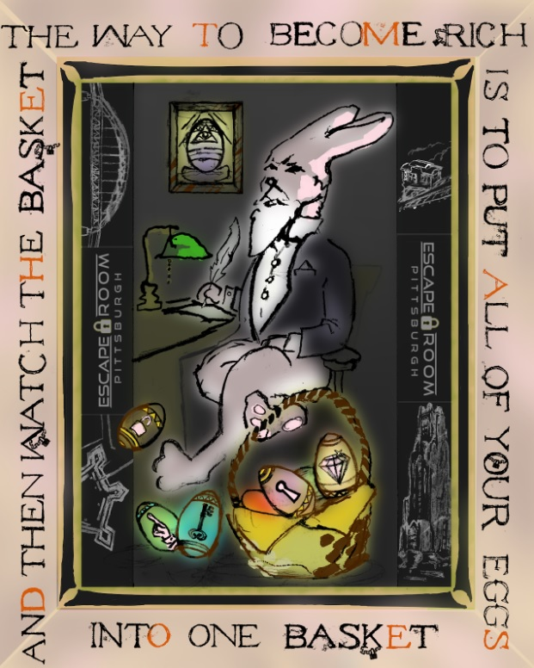

Complexity: 5 out of 5
Design timespan: 3 Weeks
Date Designed: February 2019
Client: Escape Room Pittsburgh
Description: One of Escape Room PGH’s most popular promotions was this one for easter in 2019. The puzzle is inspired by the book Masquerade in which a children’s book lead to an extremely valuable artifact buried in London. Very similar to that hunt, there are words around the outside frame of the image with certain letters highlighted/specified. The letters around the outside hold the secret to the location in which an Easter basket was hidden around the city.
- See below for a detailed description on how this puzzle is solved
- Click the “Process” tab on the main page to see how this puzzle was designed

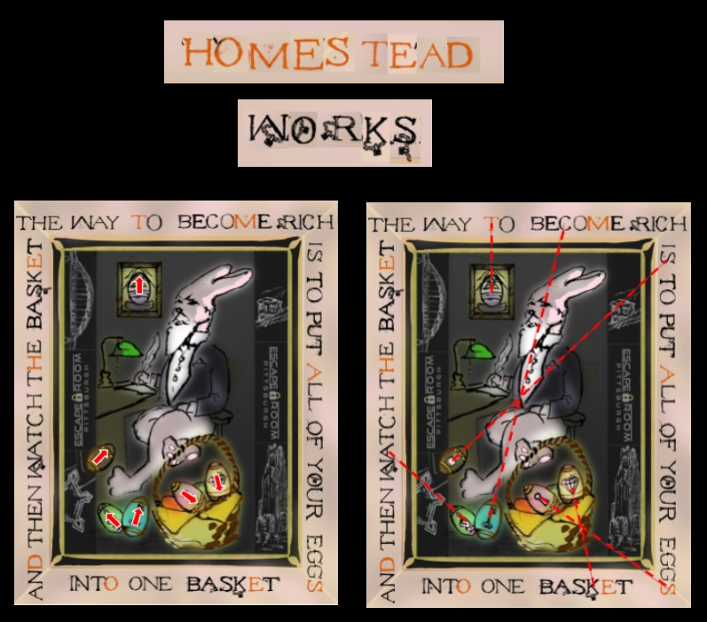
The Quote around the outside of the puzzle is a famous saying by Andrew Carnegie, a billionaire philanthropist who made Pittsburgh his home. This is only helpful for theming purposes, but also gives insight into the location being somehow related to Carnegie.

Taking the red letters and "locked" letters alone and unscrambling them, you get the phrase "Homestead Works." This is a reference to the Homestead Steel Works (Duquesne Works) which Andrew Carnegie worked on. There are several locations in Pittsburgh which you could follow with this information, but the answer is in the eggs. If you draw a physical line (as shown in the image) from the point of the symbol on each egg to the border, it will give you another letter for each egg. All six letters together spell out "STACKS" directing you to the Homestead smokestacks in the Waterfront!

