The Cube 1.0
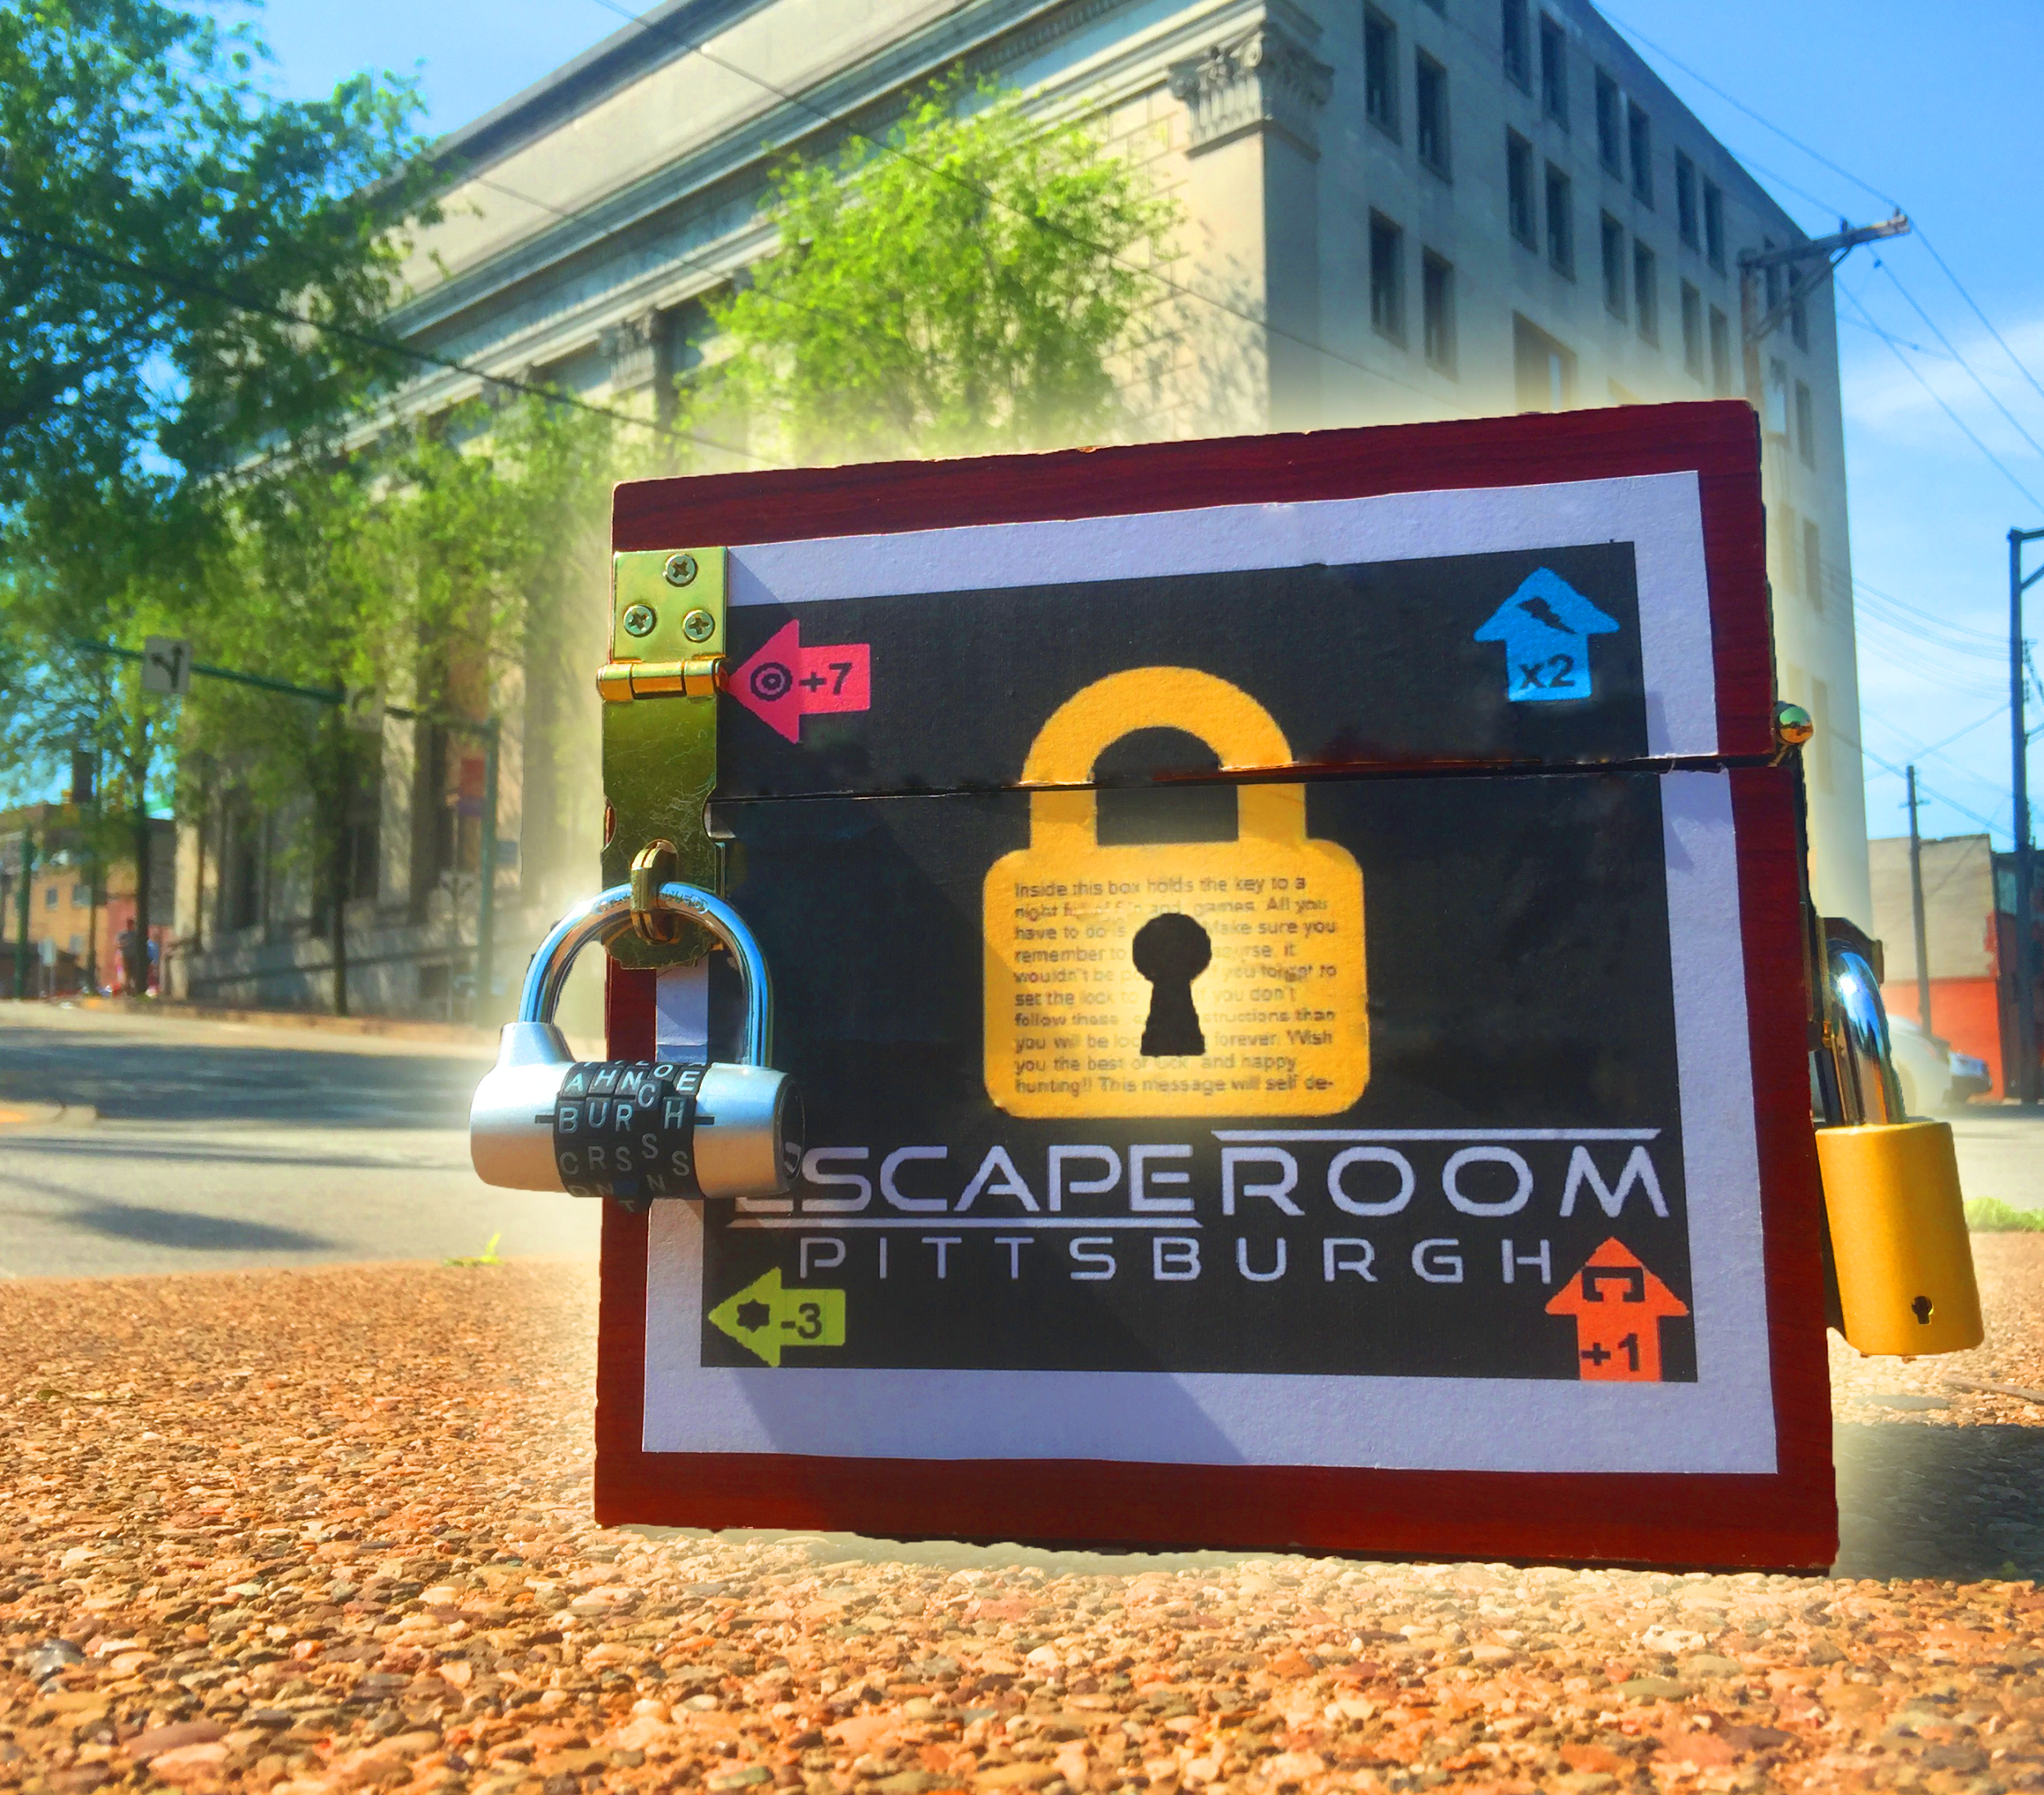

Complexity: 5 out of 5
Design timespan: 3 Weeks
Date Designed: May 2019
Client: Escape Room Pittsburgh
Description: The Cube is an interactive puzzle box resembling a sort of escape room. It was built to advertise the company, but does a good job of presenting a challenge to open as well. There are three combination locks the sides of the box keeping it shut, forcing you to solve puzzles around the box to open it. This specific box is themed like the escape room, with each side being a different room. If interested in purchasing a puzzle cube, I can either create the blueprints or put together the box itself and deliver it for an additional charge.

