Proposal by Destination
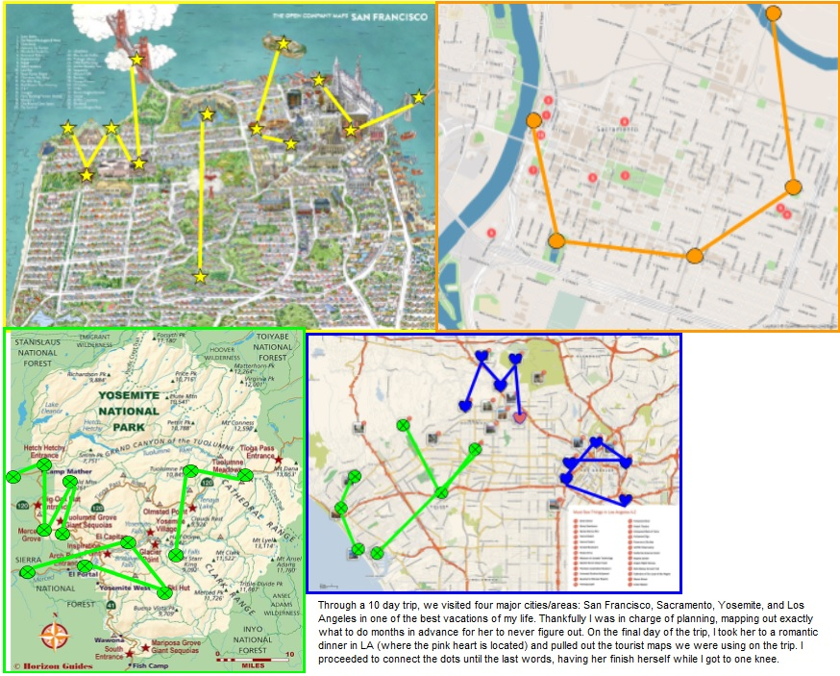

Complexity: 4 out of 5
Design timespan: Three weeks (for vacation plan to correspond with puzzle design)
Date Designed: March 2019
Client: N/A (My girlfriend)
Description: Based on the itinerary that my girlfriend and I decided on for our trip to California this past Spring, I began secretly compose a few maps with all of the locations highlighted with shapes. I had to do a little tweaking and persuading to add locations purely for puzzle purposes. Once complete, each City/park we visited spelled out a word when looking from above. At the end of our trip in Los Angeles, I took her to a nice dinner and pulled out very similar tourist maps we collected throughout our trip and began marking the locations with a sharpie. I had her connect the dots as I got down on one knee. The same maps are now getting framed to put up somewhere in our house.

